**Lab Practical #04:**

Installation of Network Simulator (Packet Tracer) and Implement different LAN topologies.

**Practical Assignment #04:**

1. **Create a simple network with switch and two or more pc. Also check connectivity between them using ping command or PDU utility.**
2. **Implement different topologies in packet tracer.**
   1. **Bus**
   2. **Ring**
   3. **Star**
   4. **Mesh**
   5. **Tree**
   6. Bus Topology Structure

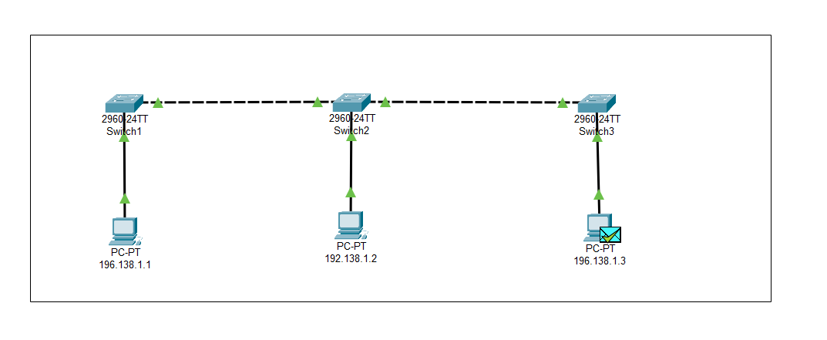

* + IP Address: 196.138.1.3

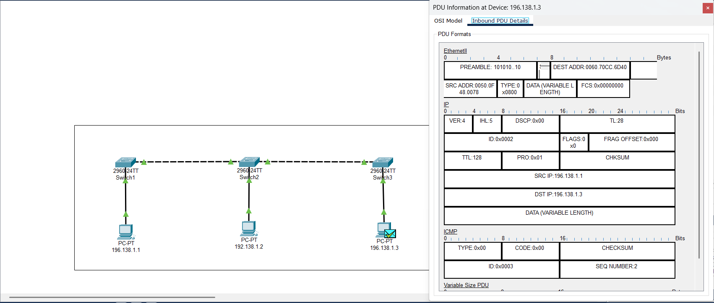

* 1. Ring Topology Structure

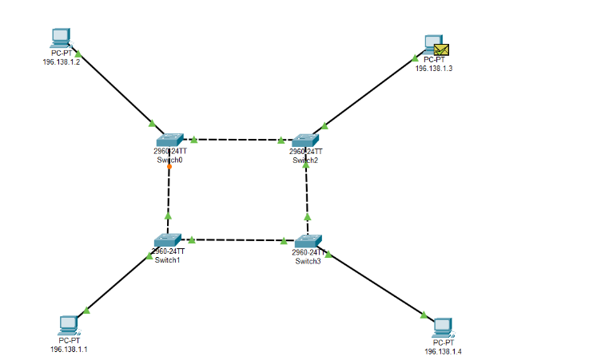

* + IP Address: 196.138.1.3

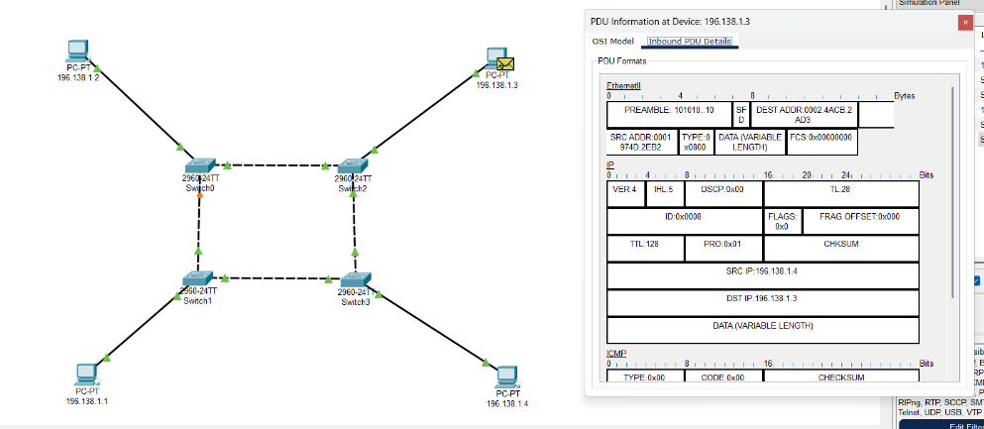

* 1. Star Topology Structure

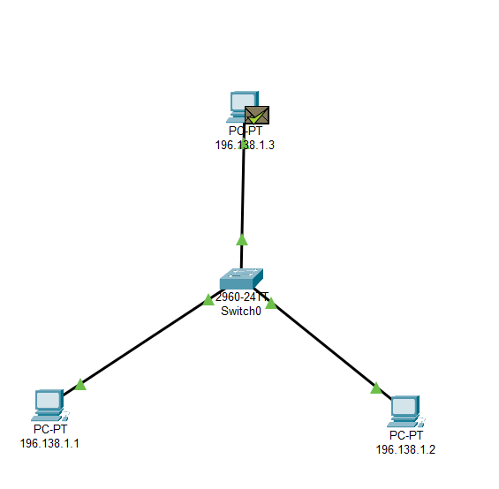

* + IP Address: 196.138.1.3

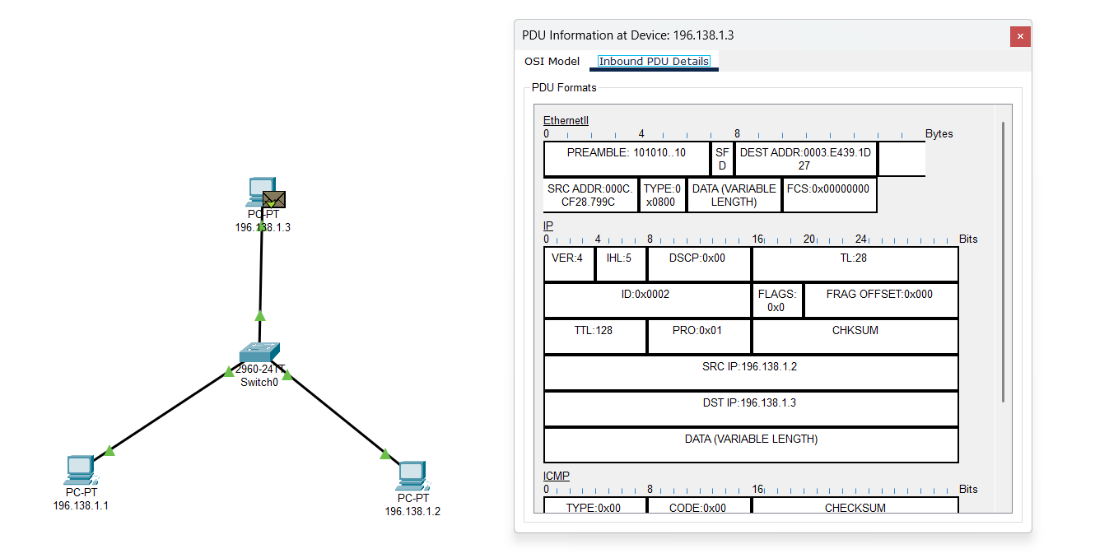

* 1. Mesh Topology Structure

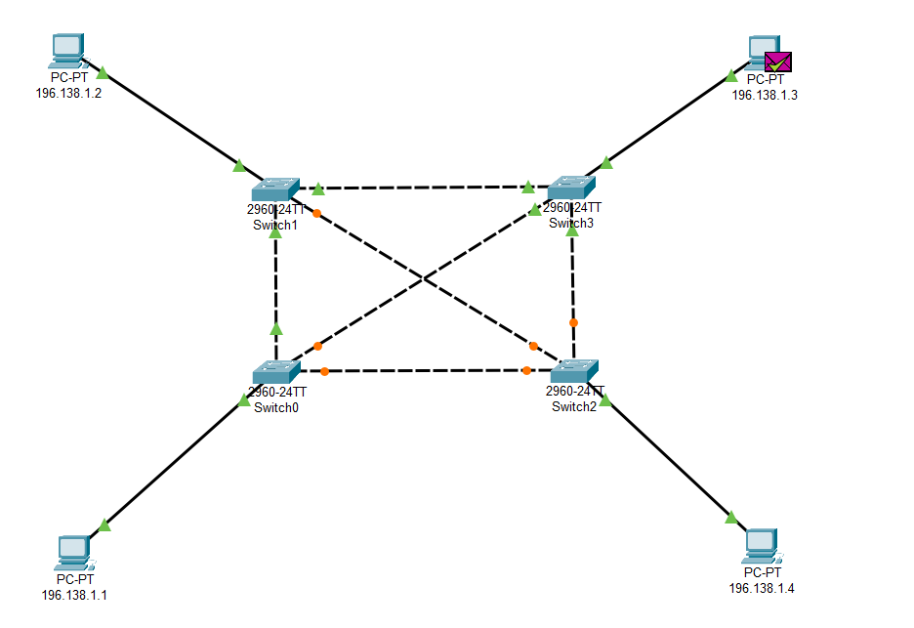

* + IP Address: 196.138.1.3

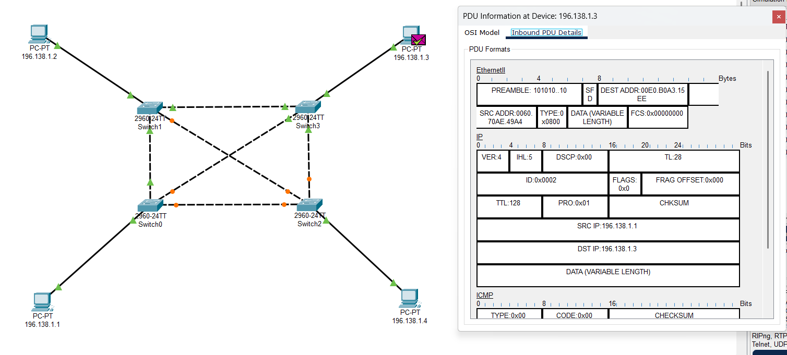

* 1. Tree Topology Structure

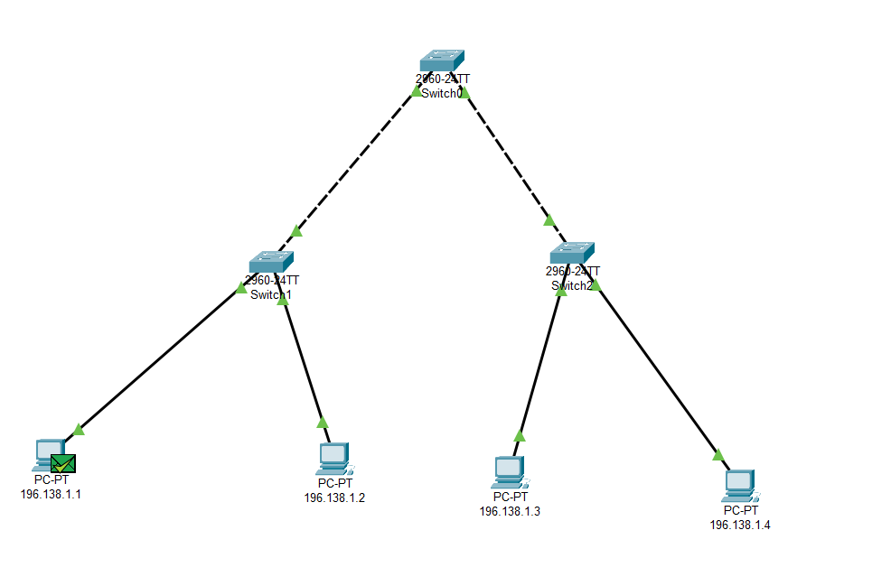

* + IP Address: 196.138.1.1

